The 2020 UI Design Fundamentals Crash course (INTERACTIVE)

**3. White Space**

White space is empty space between the elements in your user interface

***Properties which create white space:***

Between content and edges:

(top, left, bottom, right)

Padding/margin: [1.0 … 1.9] em

Between content and content (eg: <H1>, <p>)

Padding/margin: [0.1 … 0.5] em

Between lines of text: (eg: lines in a paragraph)

Line-height: [1.0 … 1.9] em

***Rules***

*“Always try to apply EQUAL space inside the container boundaries.”*

**4. Alignment**

Alignment in UI design is the process of ensuring that every element is positioned correctly in relation to other elements.

Each element in a UI defines a series of rows and columns.

***Rules***

*“Align all the UI elements in the same column”*

**5. Challenge**

**6. Contrast**

Contrast is defined as being in a ‘strinkingly’ different state from something else.

There are some rules regarding how a color should contrast with another:

***Regular standard:***

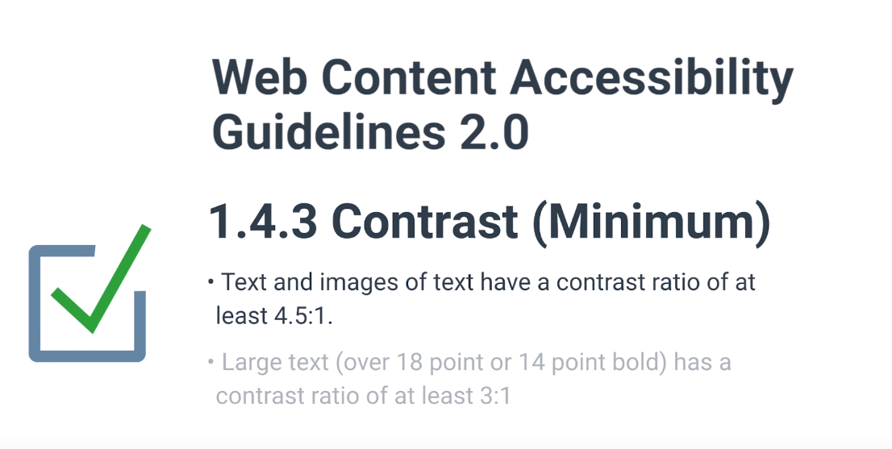

***Enhanced regular standard (old people, blind people):***

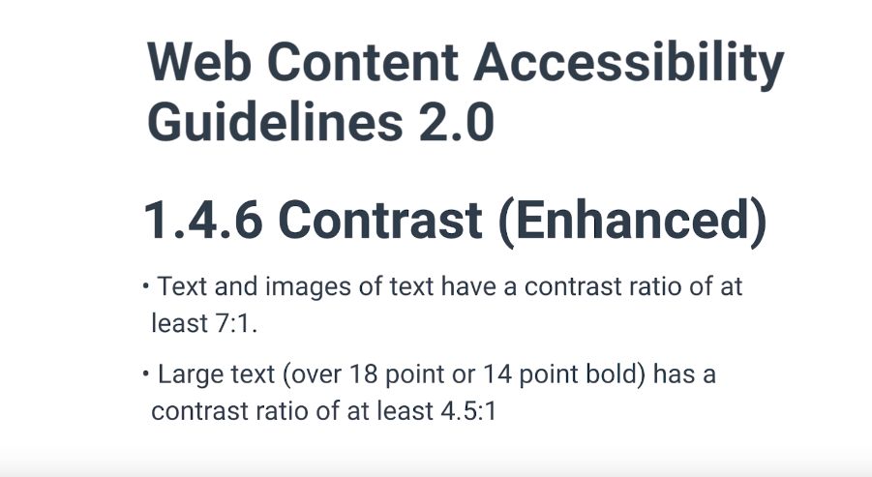

***Contrasting texts:***

Contrast inspection tool:

[Click here!](https://contrast-ratio.com/#%23fff-on-%23430bca)

**7. Scale**

Just as with alignment, white space, contrast, and the other fundamentals, the size of every UI element must be carefully considered.